PC users ~ Installing FileZilla on your computer

Go to http://NiNite.com
Select the red FileZilla icon on the rightmost column

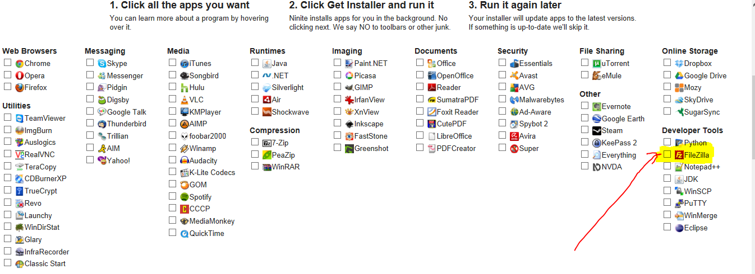

Then select the Green Get Installer button at the bottom of the page
